Root locked account of ec2?

I think this issue is for mis configuration on /etc/fstab ?

1. Stop ec2 instance has issue
2. Detach EBS from it

From ec2 -🡪 storage --🡪 open volume in new tab --🡪 Actions --🡪 Detach volume

After detach volume not its status

1. Attach volume to other ec2 instance running on same AZ
2. AZ of EBS is us-east-1f and AZ of EBS-Testing is us-east-1f
3. Select volumes --🡪 Actions ----🡪 Attach volume ----🡪

1. Select instance you want to attach ebs to.

1. Attach volume

Now EBS-Testing instance has 2 ebs volumes attached to it.

Now this instance has 3 volumes the highlighted one is instance store nvme1n1

First one is EBS that has root file system. -🡪 nvme0n1

Last one nvme2n1 is attached ebs

1. Check file system for attached ebs

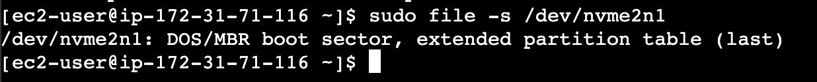

<https://serverfault.com/questions/114944/mounting-an-attached-ebs-volume-in-ec2>

<https://serverfault.com/questions/144988/root-locked-out-of-ec2>